July 11, 2022
Chapter 7
Spiritual Family & Church Life

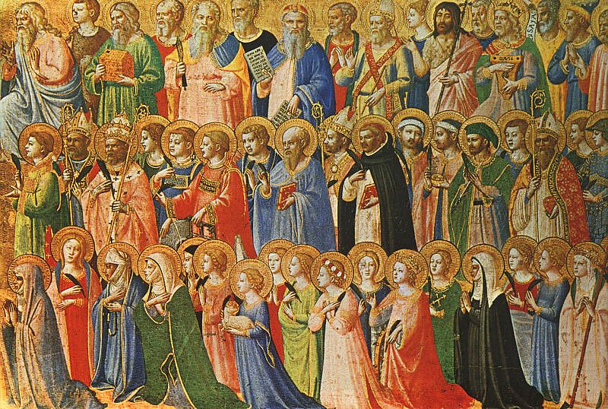
- The Victorious Church
The word “church” is from the Old English “cirice” (ki-ri-kuh), borrowed from the Greek “kyriakon”, or ‘of the Lord’. The word “ekklesia” is more common in the Roman and Greek, meaning ‘assembly’. The words “ecclesial” and “Ecclesiastes”, meaning “related to the assembly” and “preacher to an assembly”.
The church isn’t just to be a place where people gather on Sunday, but a gathering that worships the Creator, Savior, and Sanctifier of mankind. From this worship originates a community that creates art and beauty together, shares everything they have, supports one another in their time of need, encourages one another to righteousness.
The Church is the body of Christ on the earth that God created. While salvation can be found inside a pure heart, it can only be lived out through Communion with fellow followers of The Way.
- “The gates of Hades will not prevail against it.”
- Christ is the spiritual rock from which our forefathers drank
- Christ Jesus
- As a husband who sacrifices himself for her (his wife), so that she might be blameless.
- The ultimate destiny of the Church is to be holy and blameless, without spot or wrinkle
- They were devoted to the apostles teaching, fellowship, Communion, prayers.
  - The early church would have had leaders (bishops) who knew apostles first-hand, who met them and who were only one generation removed from Christ.
- There were:
  - Signs & wonders
  - Unity
  - Giving up of possessions to those who needed them
  - Daily worship and Communion together, being glad and generous
  - Having favor with one another, multiplying believers
- There was common ownership of goods, people would have sold their possessions to increase the common good of the community
  - Max Weber, John Calvin, predestination, working out of salvation through dedication to the vocation, and individualism
  - Calvinism as an encouragement of capitalist tendencies
  - The Church had prohibitions on usury
  - Wealth held by anybody but the Church was viewed as evil

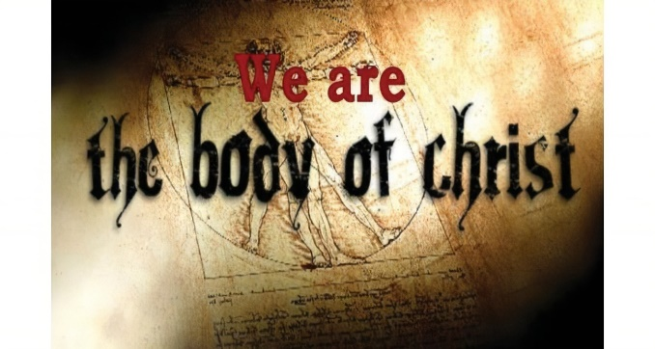

- The Body of Christ
- Members of the body of Christ
- That all members are equally important, even though they serve different roles
  - Early themes of egalitarianism
- God
- None can function without the other
- That they should be given the greater honor
  - Recognizing the importance of the sick, the weak, supporting those who need it the most
  - Christ talks about those who do not serve those who are in need as “evildoers”, and they will be forsaken Heaven
- Having the same concern one for another
- Body, spirit, hope, Lord, faith, baptism, God and father of us all
- Keep the peace given by the Holy Spirit
- That they may all be one, as Jesus and the Father are one
  - Allusions to the Trinitarian nature of God- Father, Son, and Holy Spirit
- “A perverse man sows strife…”
- One who sows discord among the brethren

- Church Leadership
Congregational, connexional, presbyterian, episcopal – Different types of polity, often with cross over of all typologies
Congregational – Ecclesiastical sovereignty or autonomy of every body (Quakers, Baptists, Churches of Christ)
Connexionalism – Bishops provide leadership over a certain polity, and each congregation has its own priorities, which can be superseded by those of the whole body (Methodism)
Presbyterian – Leadership is performed by a group / groups of elders (Reformed Church in America, Presbyterian Church USA, Living Water Fellowship, etc.)
Episcopal – Governed by bishops, practicing their authority in dioceses/synods/etc (certain geographical areas), leadership is both constitutional and sacramental (Roman Catholic, Anglican, Orthodox)
- Apostles (one sent forth with orders), prophets (interpreters of Gods mind, seers of secret things), evangelists (bringers of good news), pastors (overseer of the assembly) and teachers
- Equipping and edifying
- Until we are fully like Christ
- Spiritual maturity, we will not be tricked or deceived
- By the effective working of every part
- He had some issues to fix in the church
- (Titus) Elder (Presbyteros) - Blameless, the husband of one wife, having faithful children, not accused of dissipation or insubordination; Bishop (Episkopos)– A steward of God, not self-willed, not quick-tempered, not given to wine, not violent, not greedy for money, hospitable, a lover of what is good, sober-minded, just, holy, self-controlled, holding fast the faithful word, able to exhort and convict those who contradict
(Timothy) (Episkopos) – Blameless, the husband of one wife, temperate, sober-minded, of good behavior (kosmios), hospitable, able to teach; not given to wine, not violent, not greedy for money, gentle, not quarrelsome, not covetous, one who rules his own house well, having his children in submission with all reverence, not a novice, with a good testimony to those outside the church
- See above
- Shepherd God’s flock willingly, eagerly, being examples. What’s the reward? The Crown of Glory!

- Church Discipline
- Feed and shepherd the flock; Be on guard for others; Warn the church of evil; Strengthen, heal, bandage, bring back & seek the lost
- Recognize and esteem them; Pray for them; Be counted worthy of double honor; Remember them; Obey them & be submissive
- Christ
- Jesus Christ
- Go directly to them and ask for forgiveness
- Go and tell them their fault in secret; Take one or two of you; Tell it to the church (Don’t skip these steps!)
- They should not be associated with, Don’t eat with them
- Illegitimate
- God’s holiness
- “The peaceable fruit of righteousness”

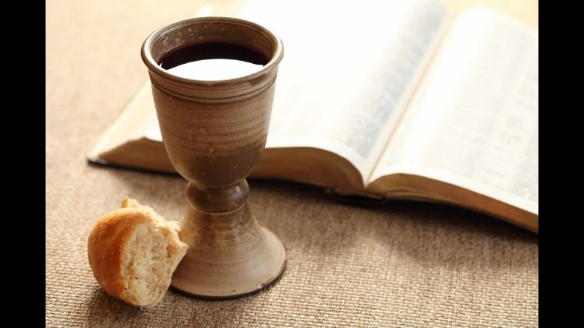

- Holy Communion
Eucharisteo – giving thanks ; also used in Matthew 15:36
Varies from assembly to assembly, but is the most typical and nearly universal thing that all Christian believers share in common. Format varies depending on the tradition. More liturgically structured churches explicitly and centrally focus on the Eucharist (celebration) of Communion with Jesus Christ. Names include: the Bread of Heaven, the true bread, bread of life, the Eucharist, Love Feast, Lord’s Supper.

Structure can look like this: the Gathering, the Greeting, the Prayer of Preparation, the Prayer of Penitence, the Gloria, the Collect of the Day, the Scriptures, the Gospel, the Sermon, the Credo, Prayers of Intercession, the sharing of the Peace, the Preparation of the elements, the Eucharist, the Lord’s Prayer, the Breaking of the Bread, the Giving of Communion, the prayer, the Dismissal (borrowed from the Church of England Book of Common Prayer). Other formats may follow a typical structure, or be more or less elaborate. Typically involving music and words focusing on the death, burial, and resurrection of Jesus, and in giving thanks for all of these things.

- The prayers and the breaking of bread
- The Lord’s death
- We are guilty of the body and blood of the Lord
- We should examine ourselves
- We will be guilty of the body and blood (crucifixion) of our Lord
- Weakness, sickness, death
- By first judging ourselves
- To help us not to be condemned by the world

For further reading: Mark 14:22-26; Luke 22:14-20
John 6:22-59

Questions? Comments? Arguments?

